

***INSTITUTE OF INFORMATION TECHNOLOGY***

***JAHANGIRNAGAR UNIVERSITY***

**Final Assignment**

**Course Tittle :** Digital Logic Design

**Course Code :** ICT – 2103

**Submission Date :** 03/08/2021

**Submitted To Submitted By**

[Dr. Md. Sazzadur Rahman](https://juniv.edu/teachers/rhemel) Md. Shakil Hossain

Associate Professor Class Roll – 2023

IIT – JU Exam Roll – 192340

IIT – JU

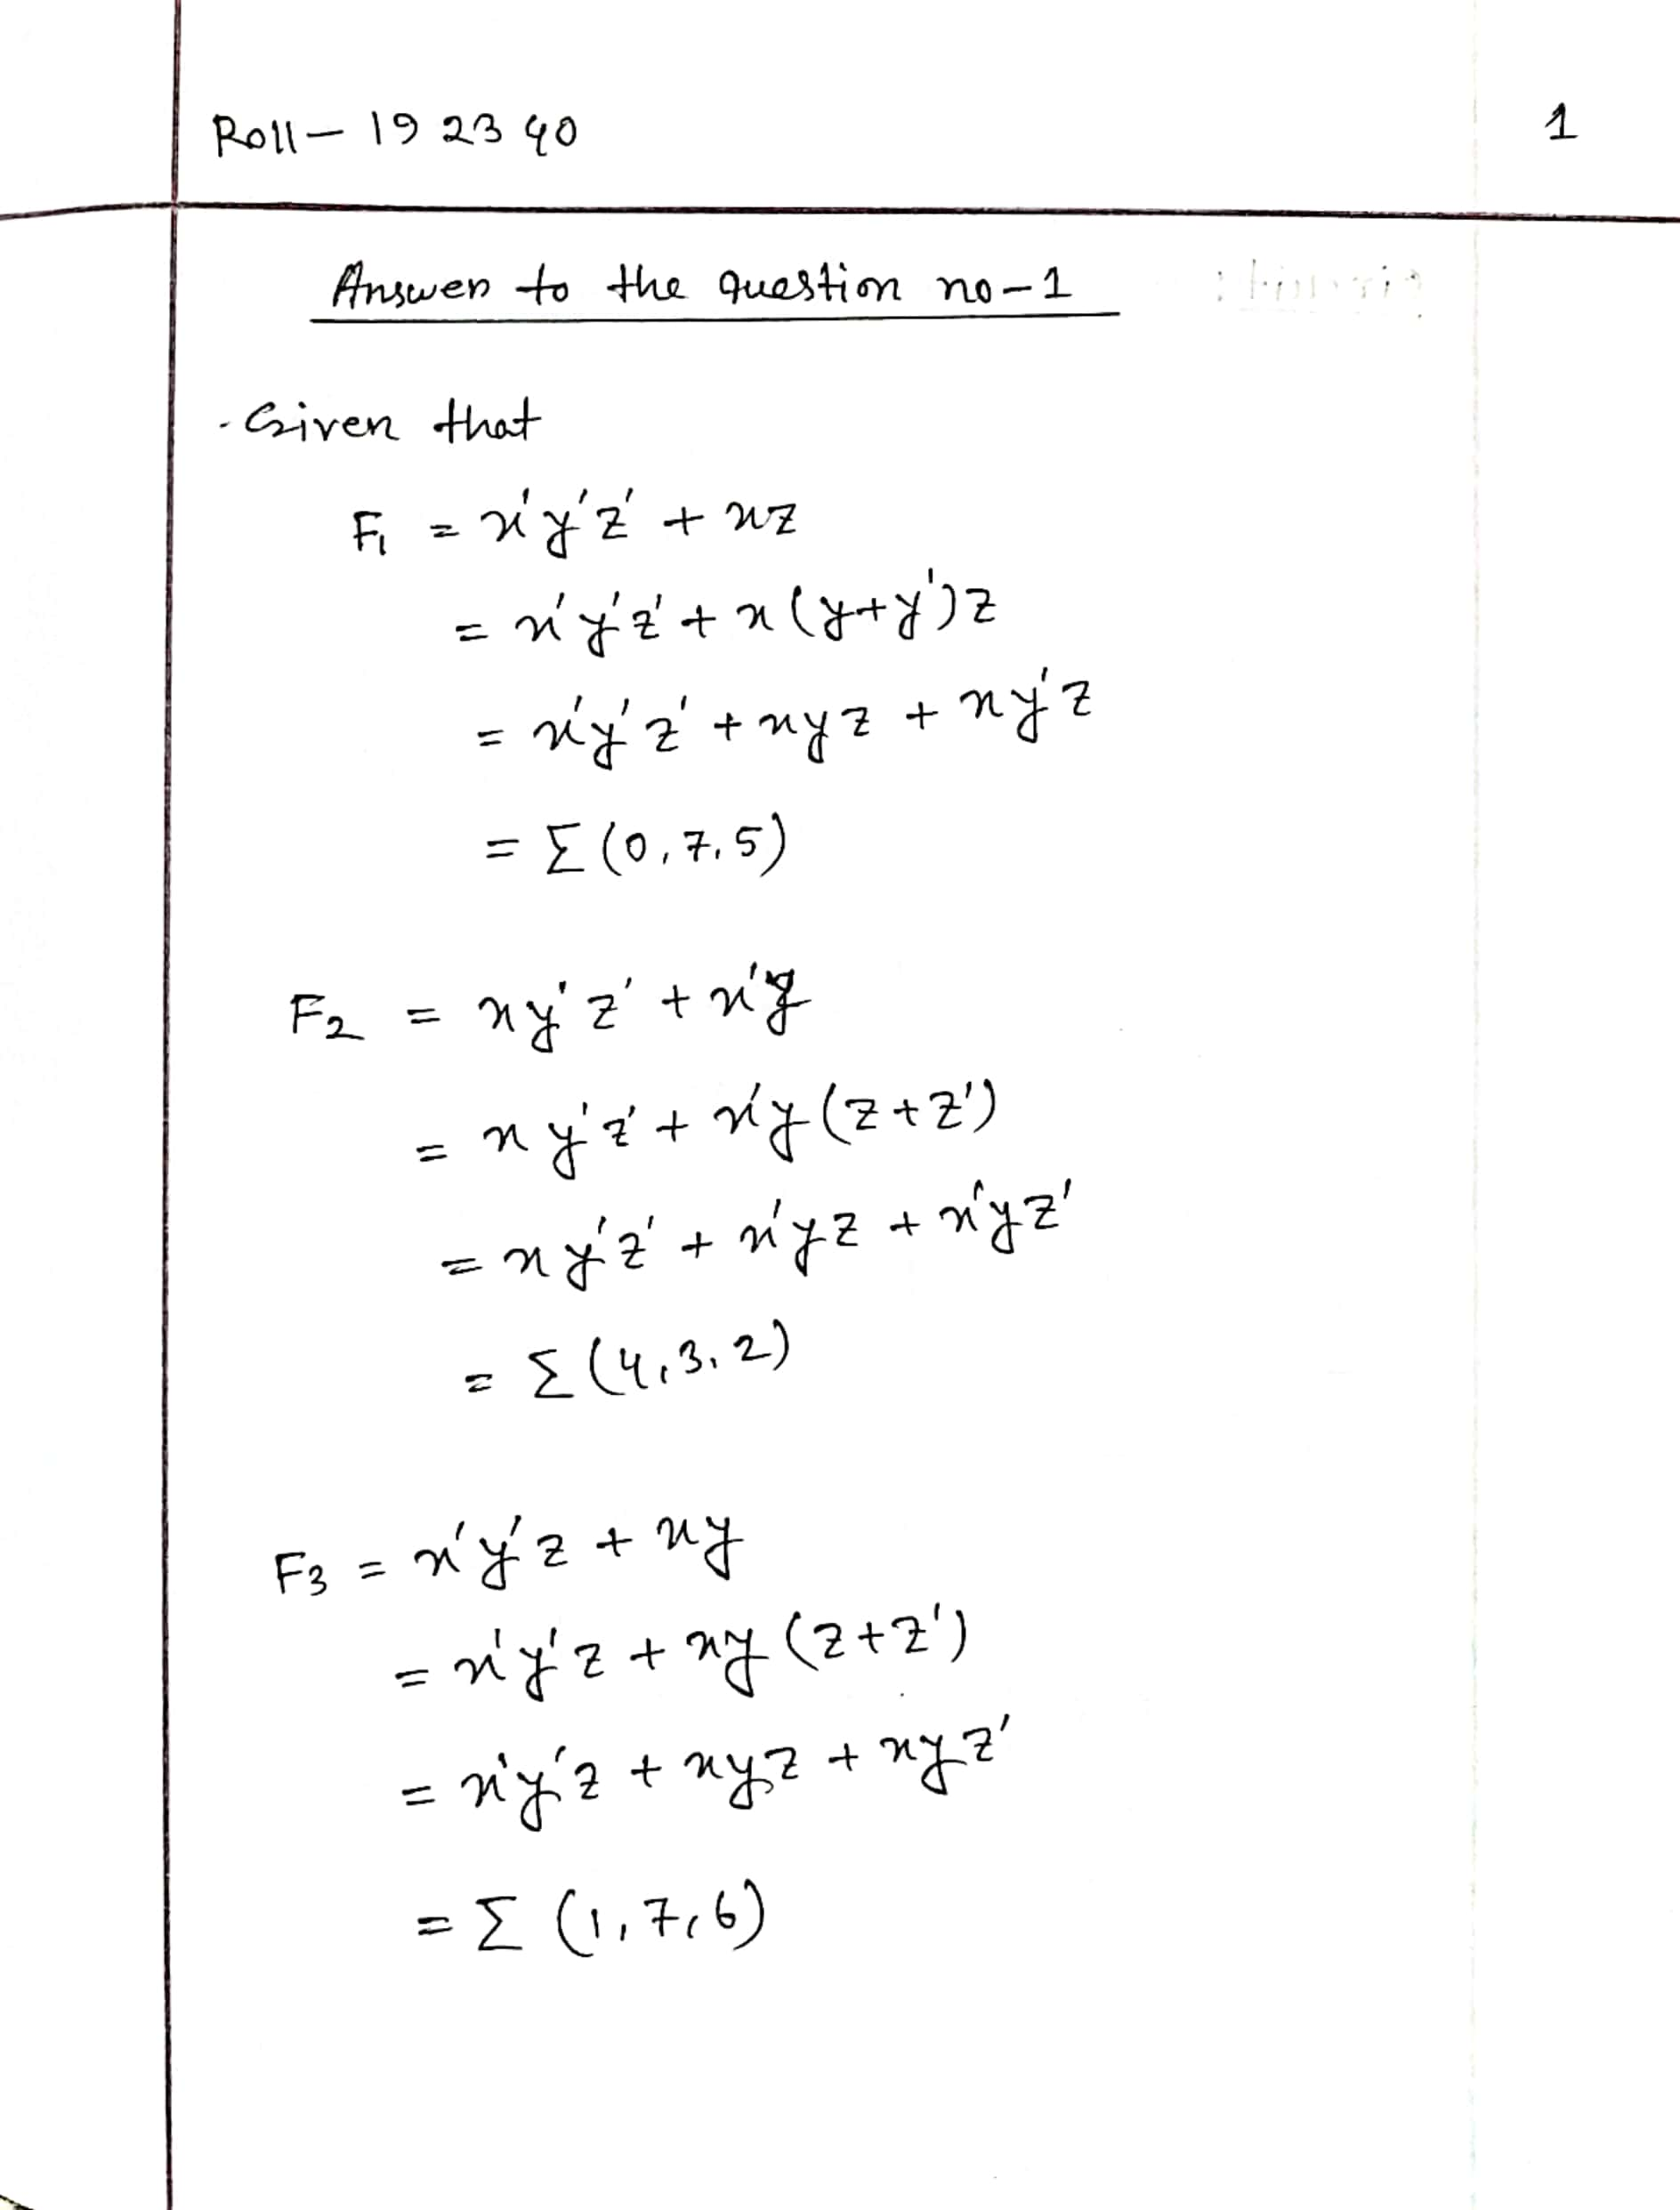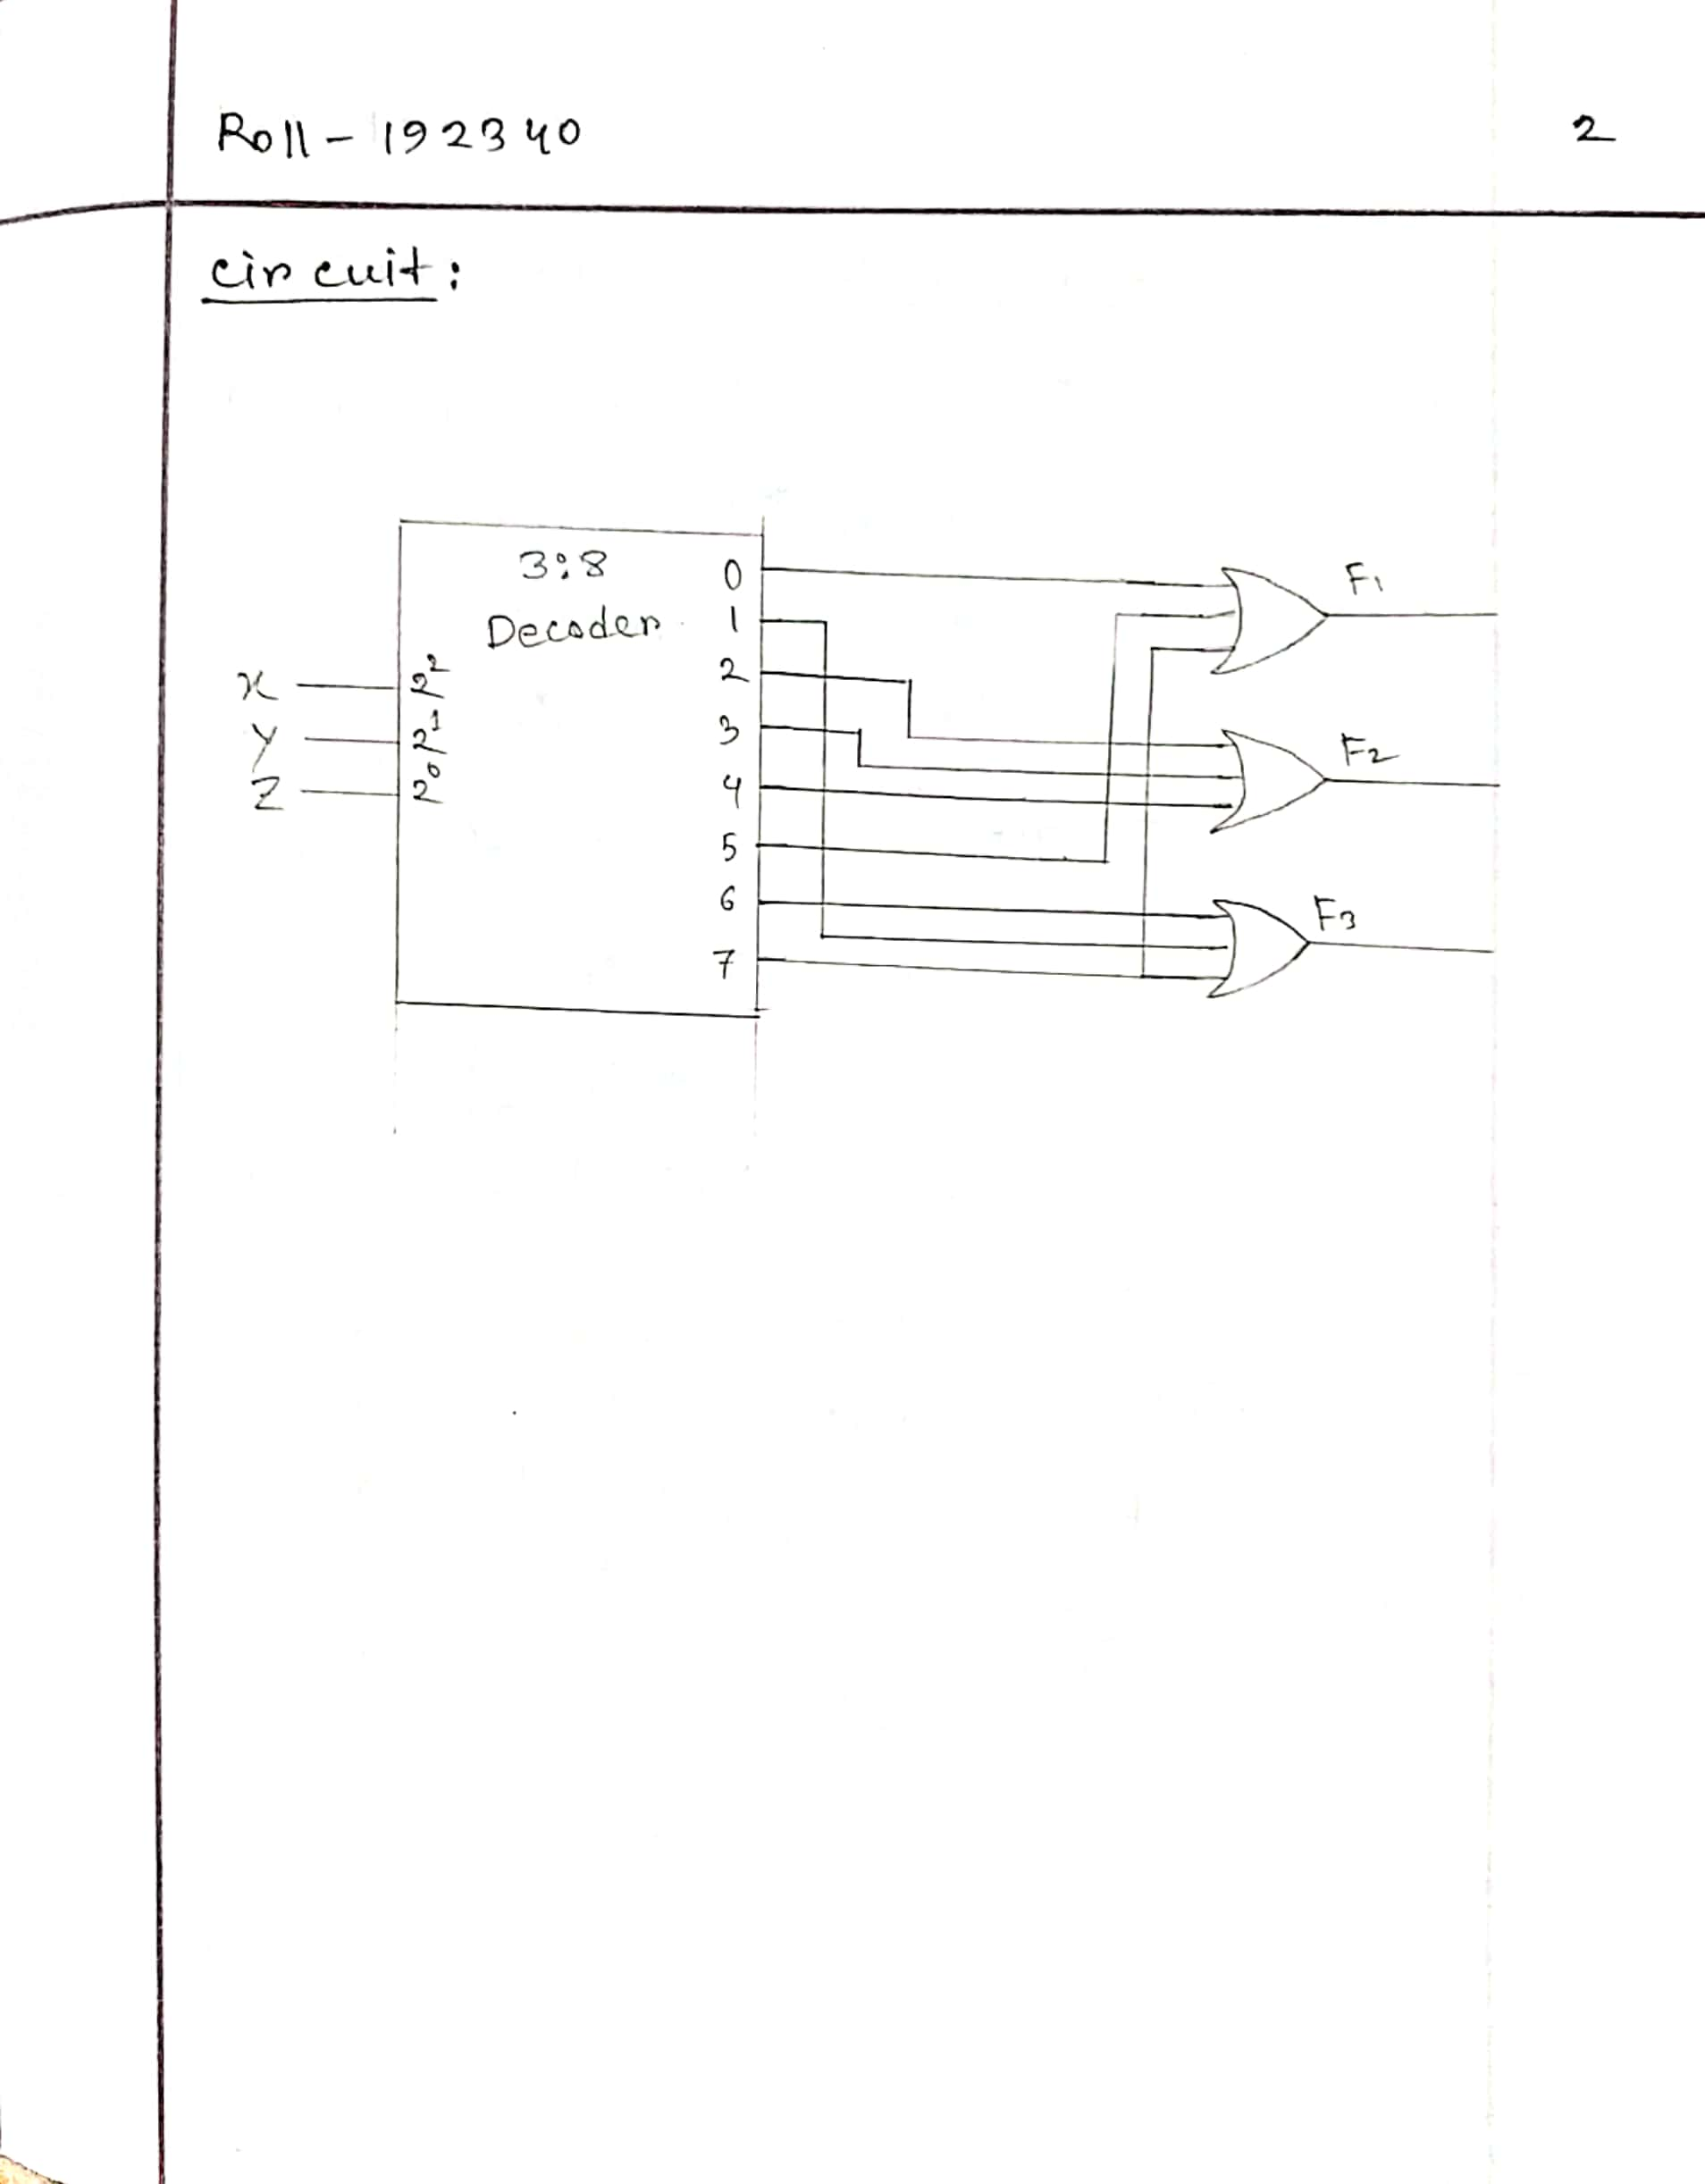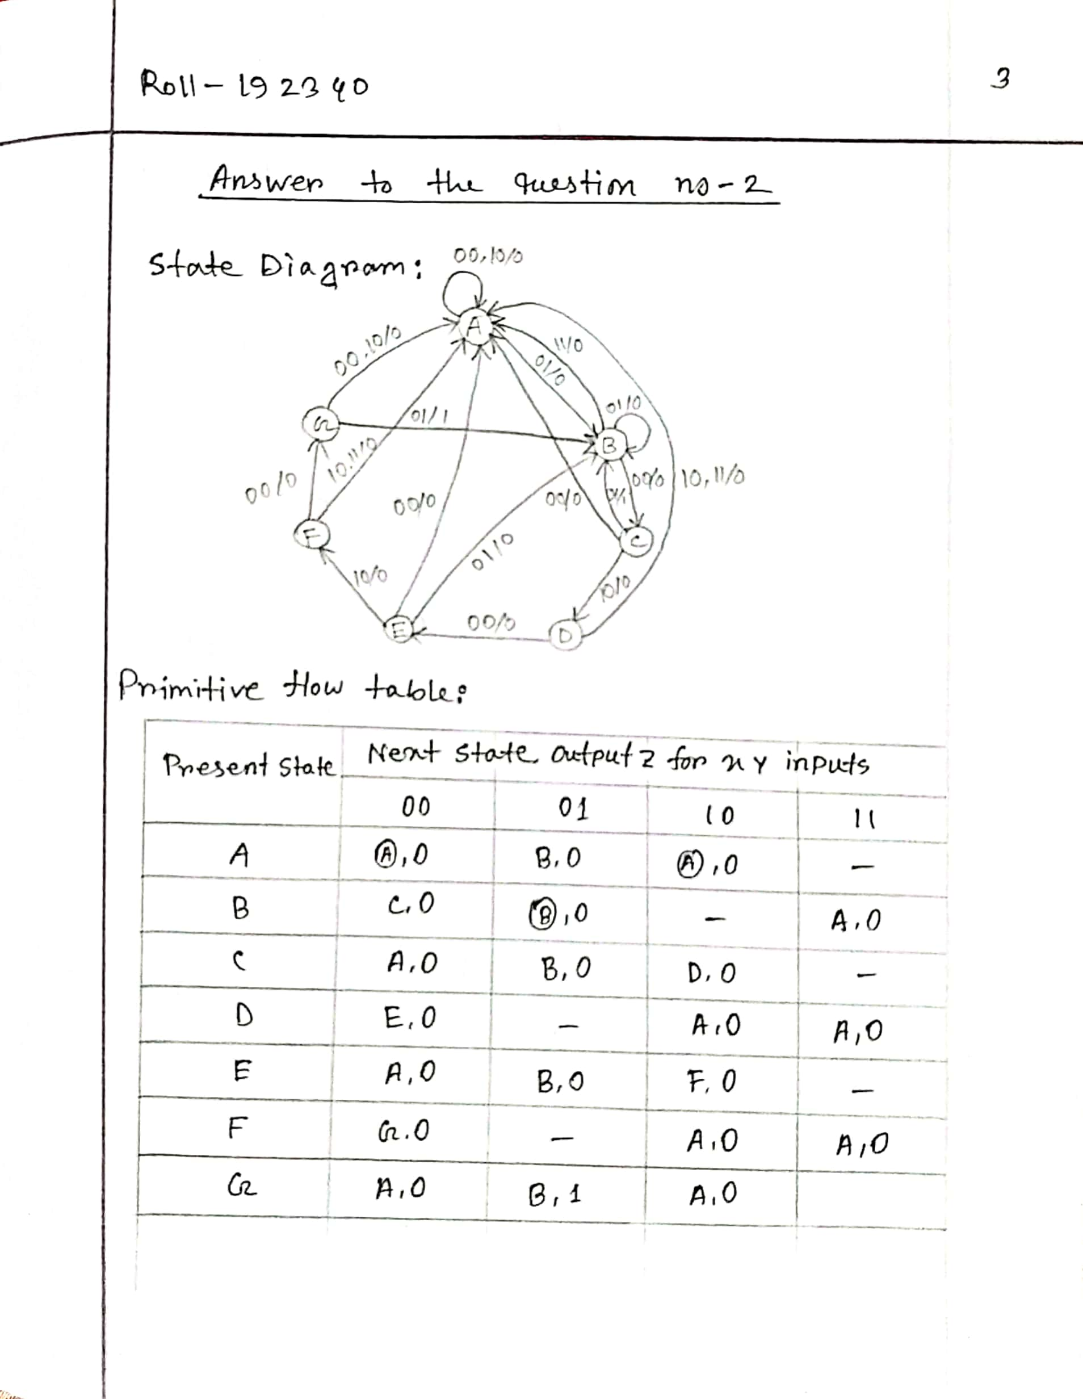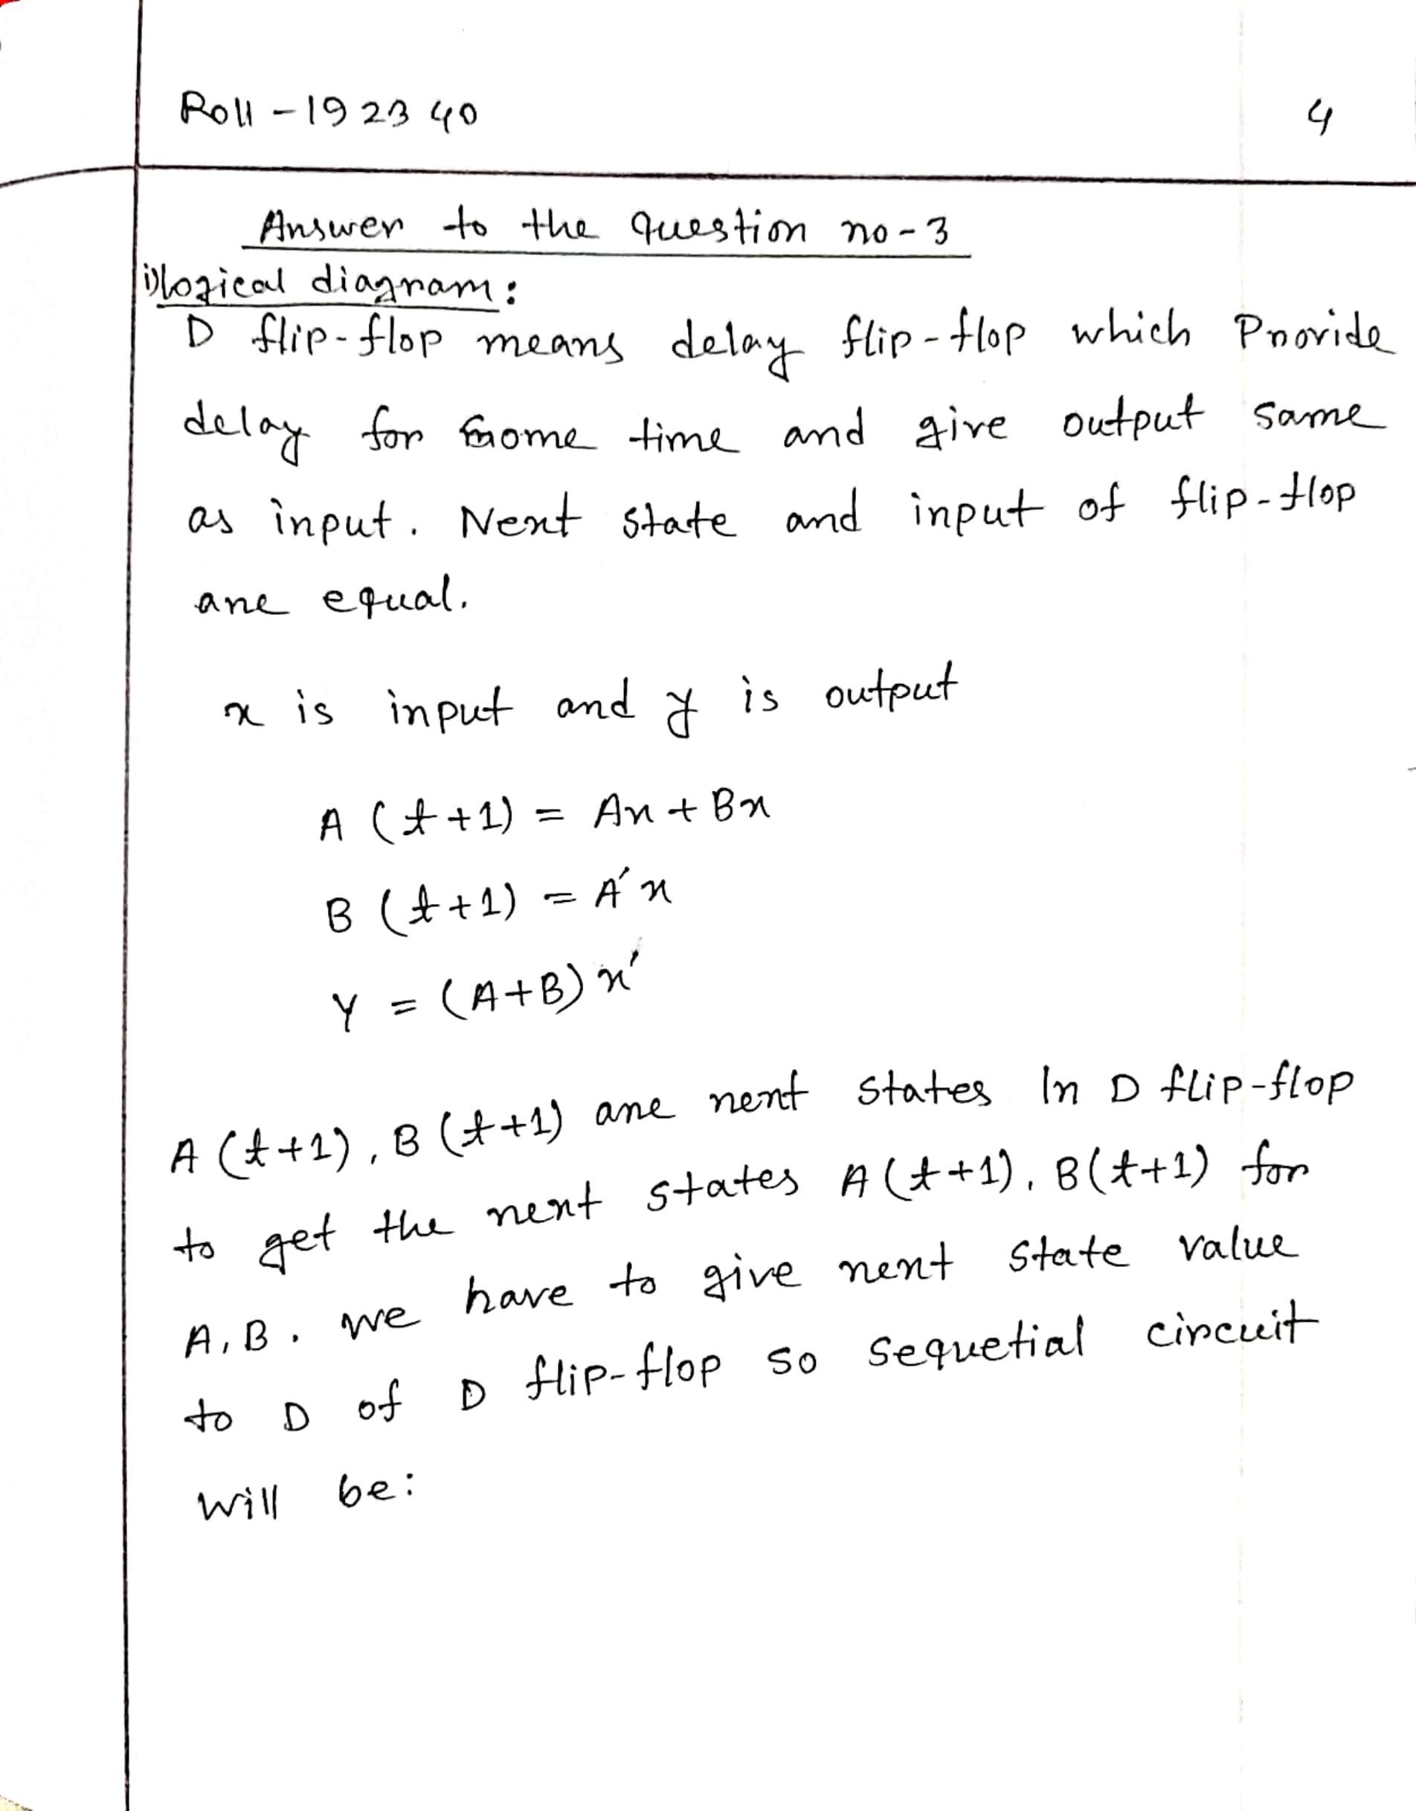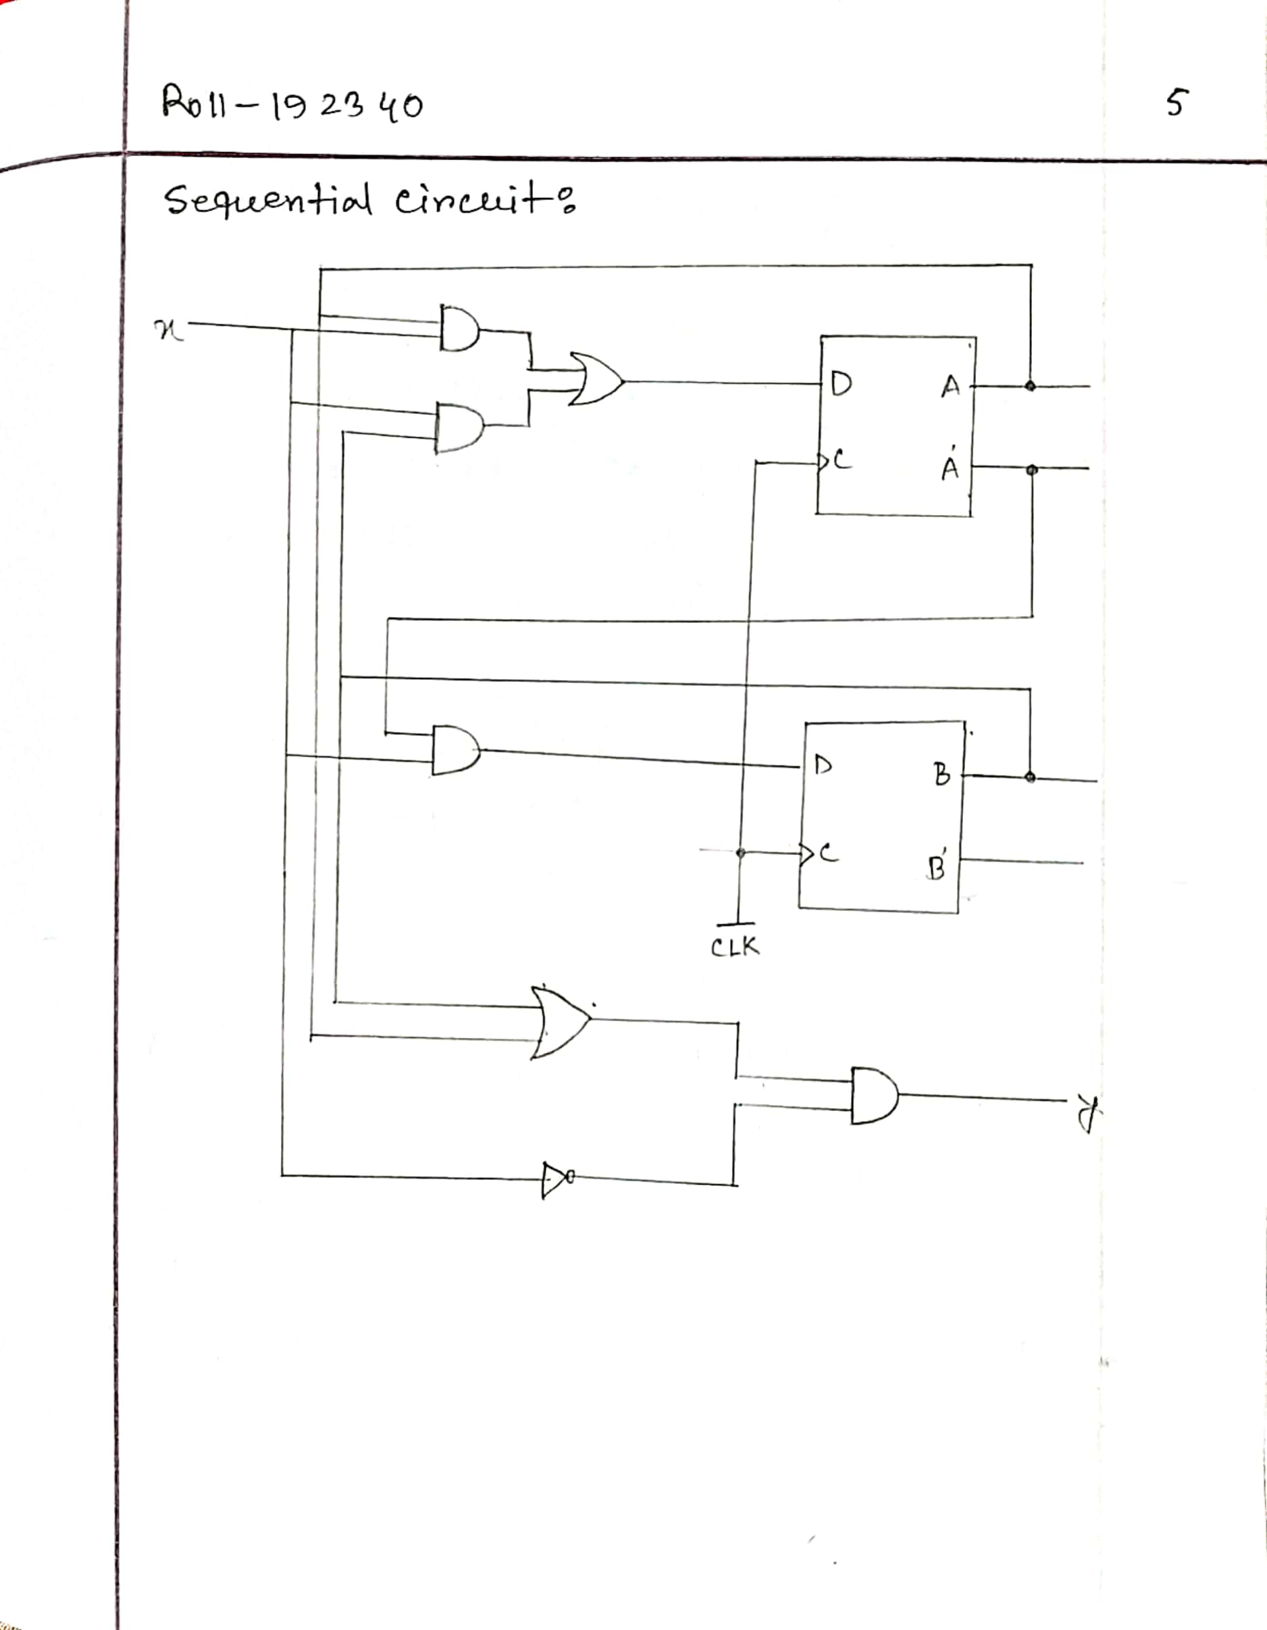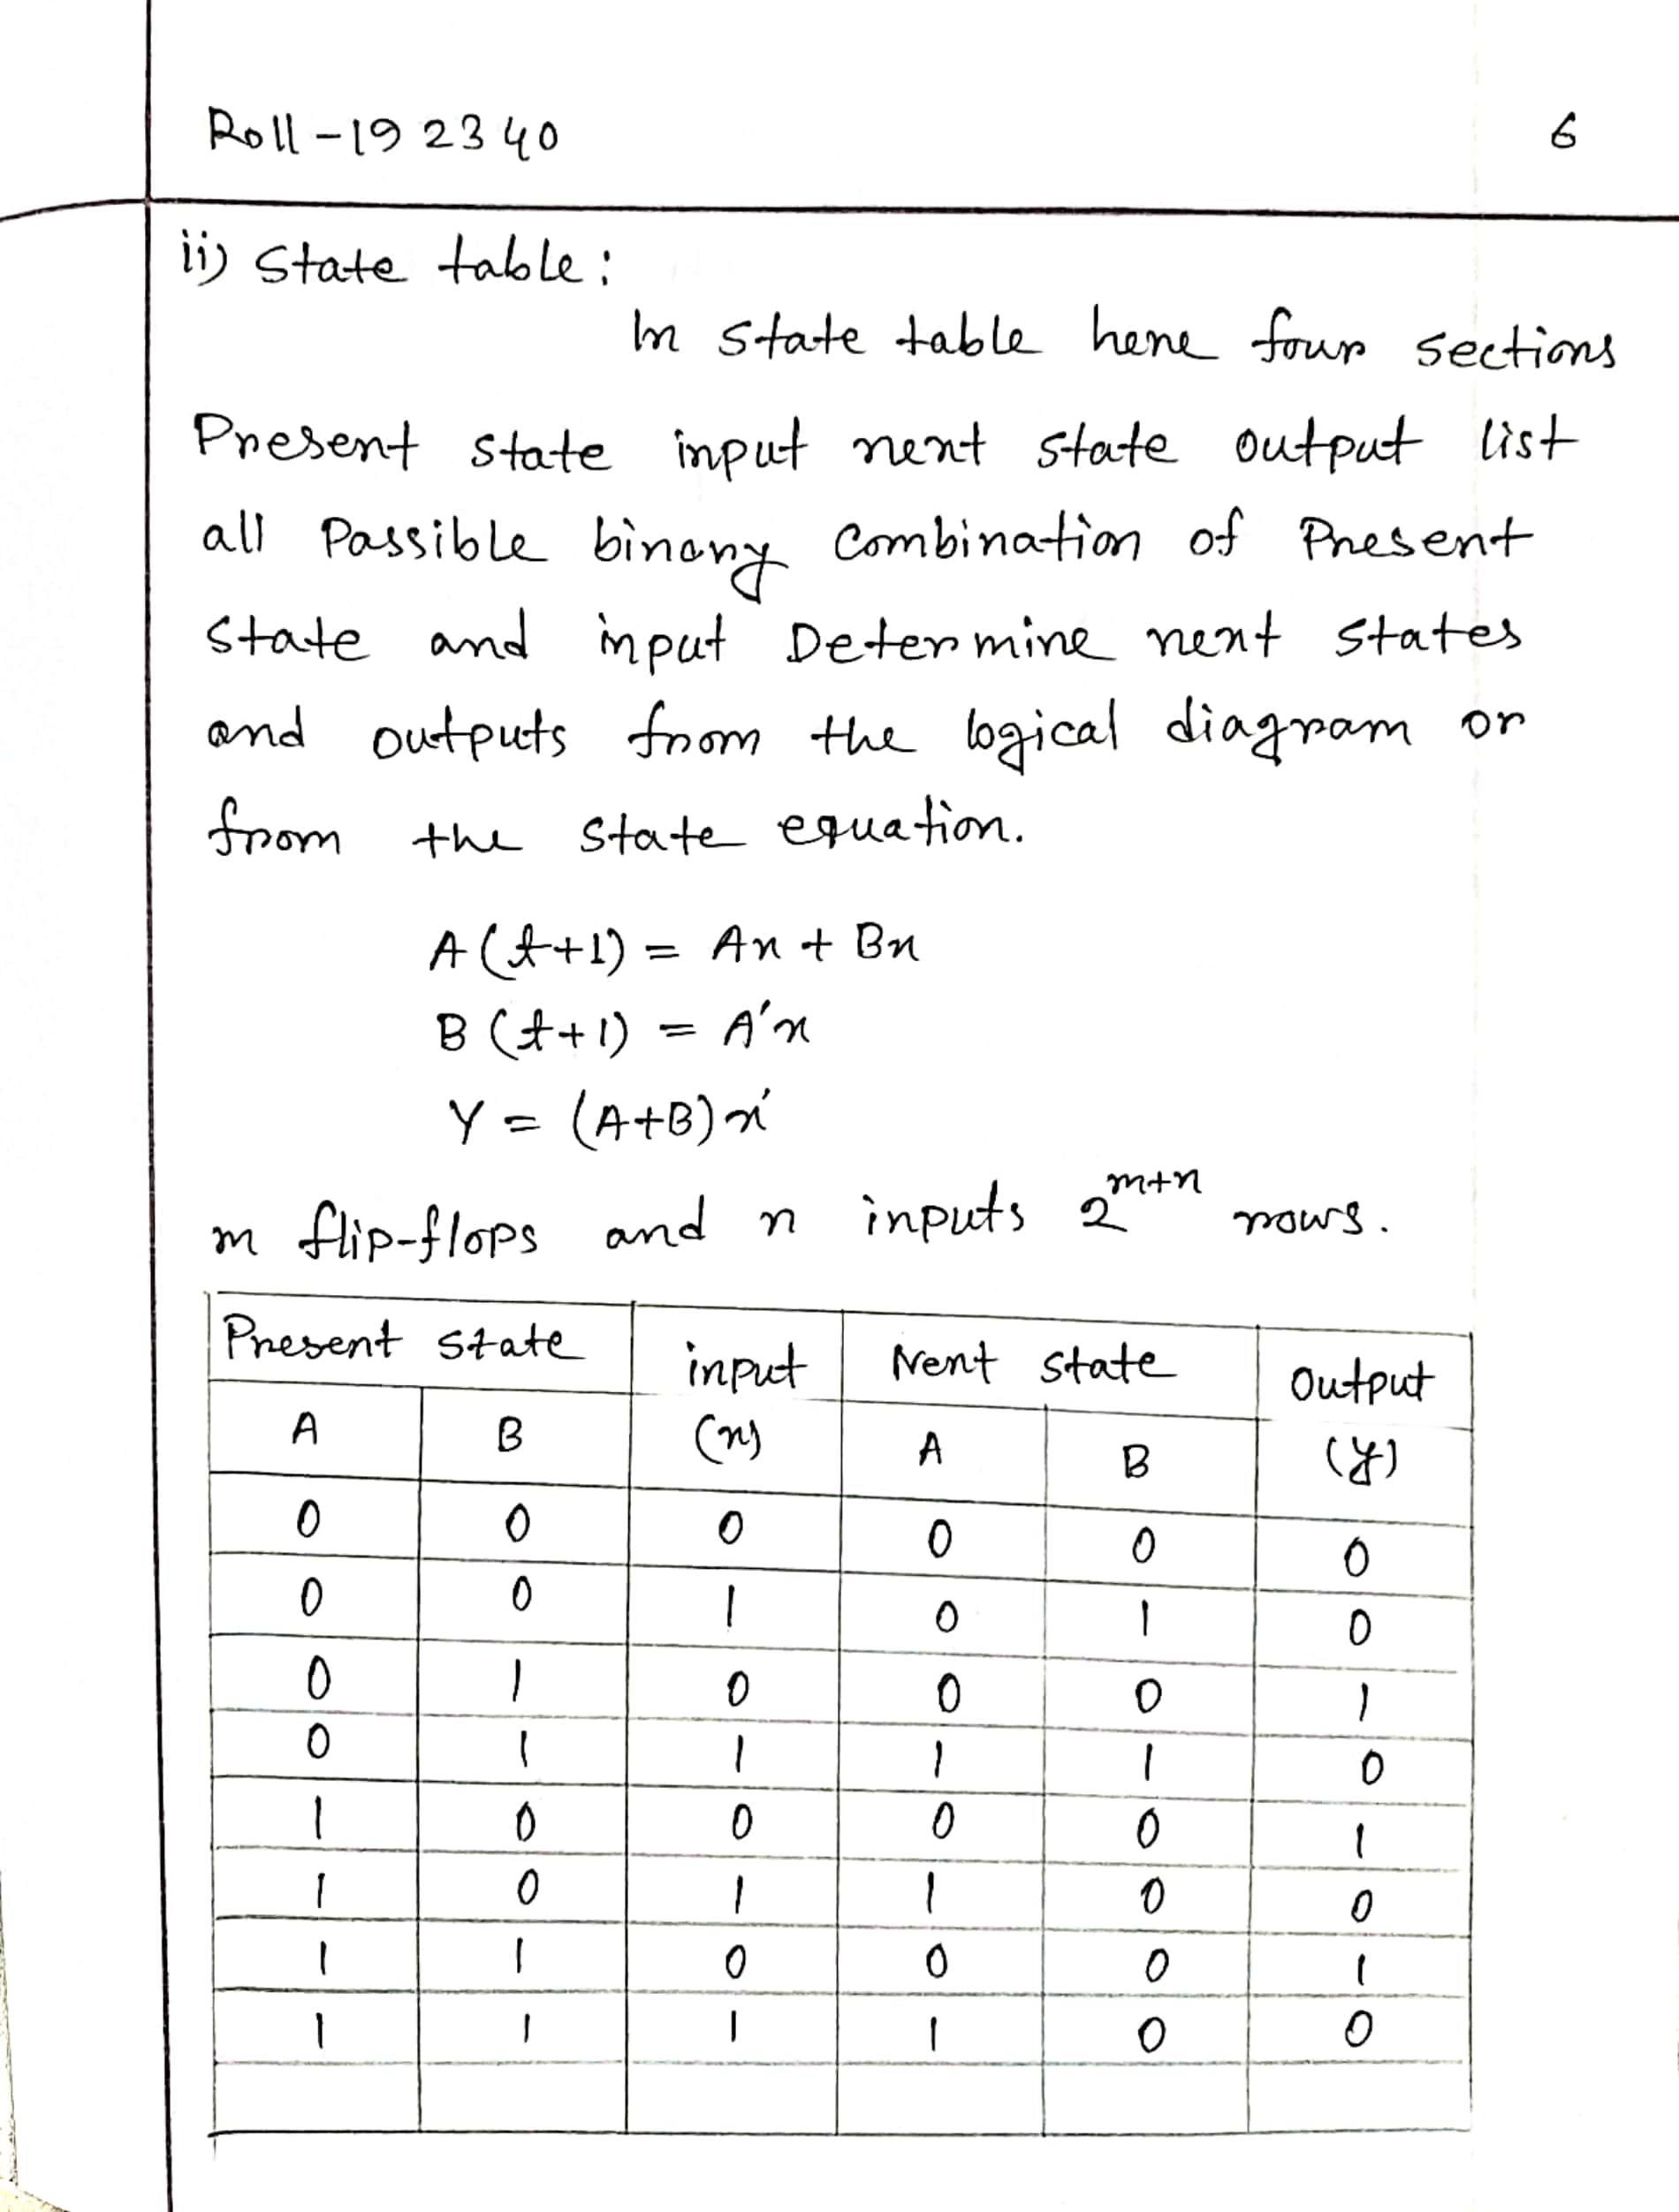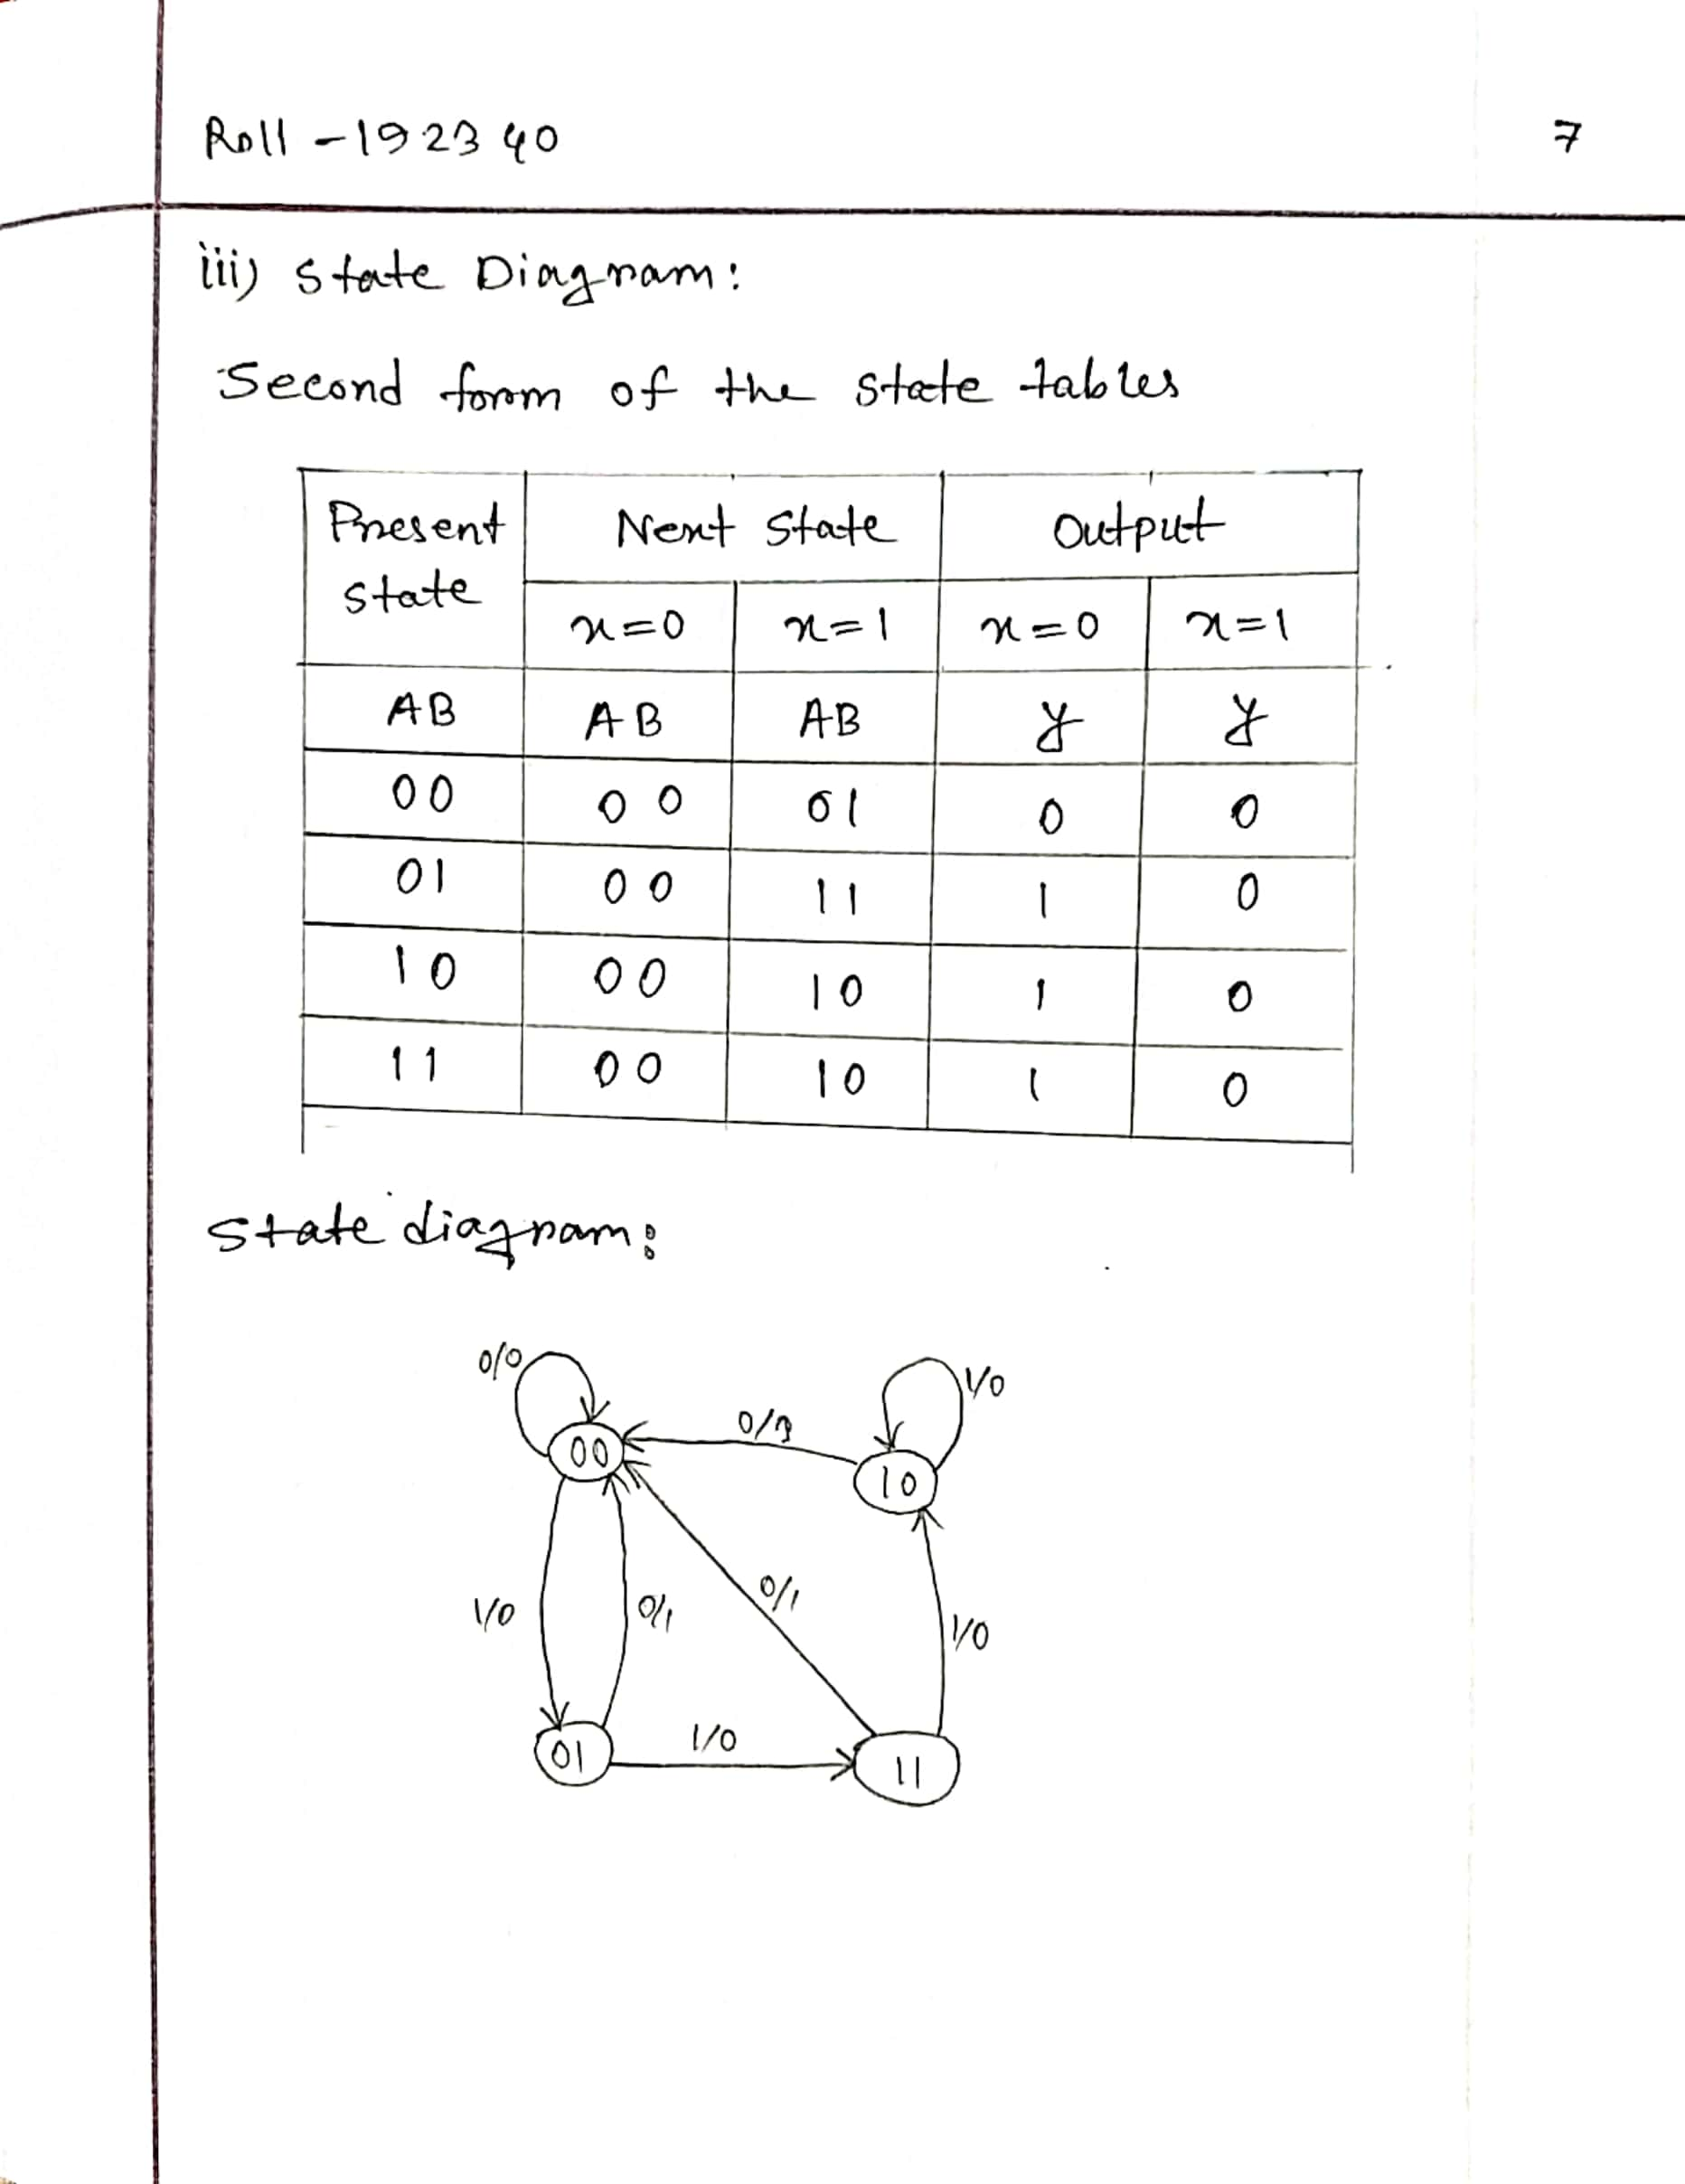

**THE END**